TrackNetV5-Lite+: Tracking High-Speed & Tiny Objects in Sports Project Report
Course: CSPC72 - Deep Learning Techniques, Semester VII
Name | Roll Number | Contact Number | Email ID
Harshit Meena | 106123047 | 9351113496 | meenaharshit161189@gmail.com
Viraj Mankani | 106123079 | 8591410685 | mankaniviraj55@gmail.com
Md Bahul Islam | 106123081 | 7667564815 | bahulislam999@gmail.com

Abstract. We re-implement TrackNetV5 (Tang, Chen & Jiang, arXiv:2512.02789, Dec 2025), the newest heatmap network for tracking tiny, fast balls in sports broadcasts, and propose TrackNetV5-Lite+. It adds five changes (M1–M5) that each fix one weakness we identified in the paper's design. Models are pre-trained on a procedural broadcast simulator and fine-tuned on the real TrackNet tennis dataset (games 1–8), then tested on two unseen matches (games 9–10). Our final model uses 0.13× the parameters and 0.16× the FLOPs of the faithful V5 and runs about 2–3× faster on a Tesla T4. On the two unseen test matches it reaches an F1 of 0.841 against 0.918 for the faithful TrackNetV5 (Section 7).

1. Problem statement
The goal is to locate a tennis ball in every frame of a broadcast video, including frames where it is tiny, motion-blurred or hidden, accurately enough to rebuild its trajectory. Standard object detectors fail at this for four reasons:
Difficulty | Why standard detectors fail
Tiny size: 5–15 px wide in a 1280×720 frame (~0.01 % of the image) | CNN backbones downsample by 16–32×, so the ball disappears from the feature map; no anchor box is that small
High speed: 30+ px per frame on serves and smashes | The ball smears into a faint, semi-transparent streak whose shape changes with its velocity
Occlusion by players, rackets and the net | The ball is simply not visible for several frames; only temporal context can recover it
Clutter: court lines, shoes, crowd, logos | Many static blobs look exactly like the ball in a single frame; motion is the cue that separates them
The task matters for line calling, broadcast graphics, player analytics and coaching tools. We frame it as heatmap regression from short stacks of consecutive frames, the approach of the TrackNet family, and ask whether the newest member, TrackNetV5, can be made both more accurate and much cheaper.

2. Gaps identified
We found five gaps in TrackNetV5 as specified in its paper; each maps to one of our modifications.
# | Gap in TrackNetV5 | Consequence | Our fix
G1 | Training target is a binary disk of radius 30 px (at 1280 px), about 60 px wide, while the ball is 5–15 px | Every pixel in the disk is equally "ball", so the peak carries no centre information; the decoded centre (bounding box of a thresholded blob) is biased, and nearby blobs merge | M1
G2 | Motion maps apply |x| to values that are already ≥ 0 after a ReLU, with one shared slope and threshold for both polarities and both frame pairs | Arrival and departure of the ball are thresholded identically; the direction of travel is left implicit | M2
G3 | The Transformer refinement head is trained on Dropout(Draft) but run on Draft + motion maps at inference | The head never sees its test-time input during training, and the fusion weight never receives a gradient | M3
G4 | 14.8 M parameters and ~117 GFLOPs per forward pass (full width) | Too heavy for edge or CPU deployment in stadium cameras | M3, M4
G5 | The authors' stated limitation is false positives in complex backgrounds, and V5 drops the occlusion recovery that TrackNetV3 had | Isolated wrong detections survive; frames where the ball is hidden are lost | M5

3. Proposed architecture diagram
TrackNetV5-Lite+ keeps TrackNetV5's three-frame, heatmap-based pipeline and changes six of its nine stages (M3 changes two of them).
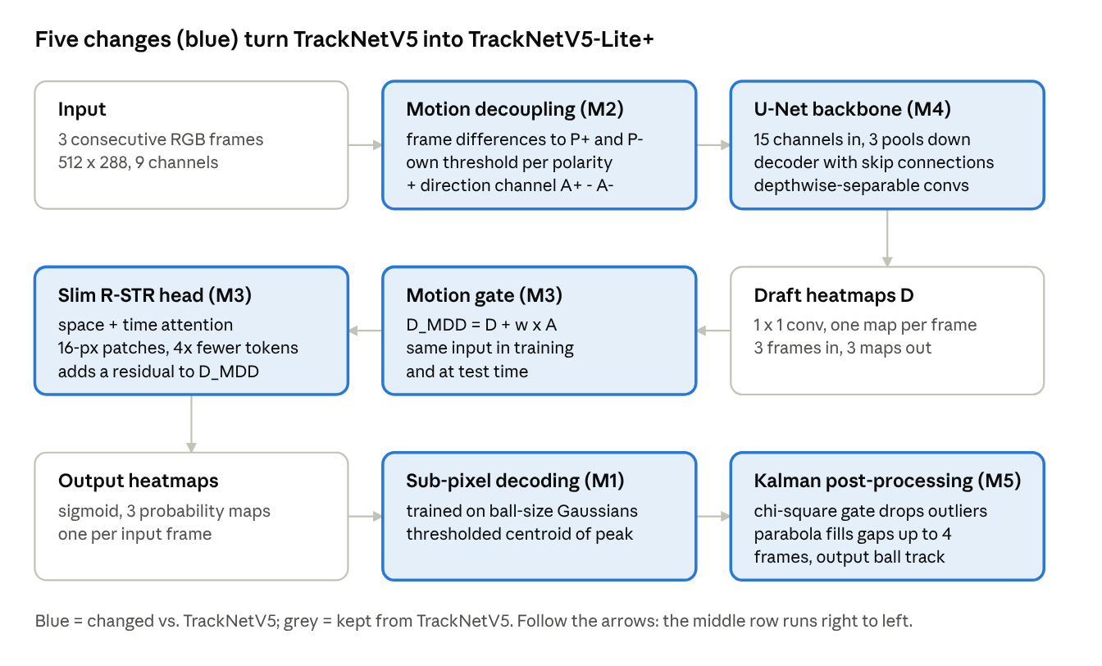
TrackNetV5-Lite+ pipeline · 9 stages, 6 changed by the five modifications
The network reads three frames and returns one heatmap per frame (multi-input, multi-output). The detailed version below shows every block's output shape and parameter count, measured from the model with forward hooks (total 409,995 parameters at half width).
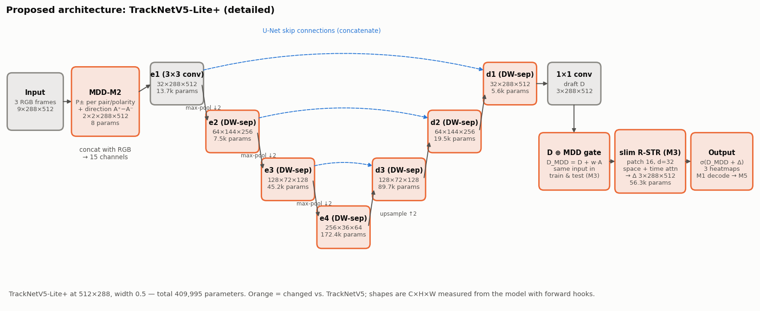
M1 changes what the network is trained to output: a Gaussian sized to the ball, whose peak marks the true centre, instead of V5's wide binary disk.
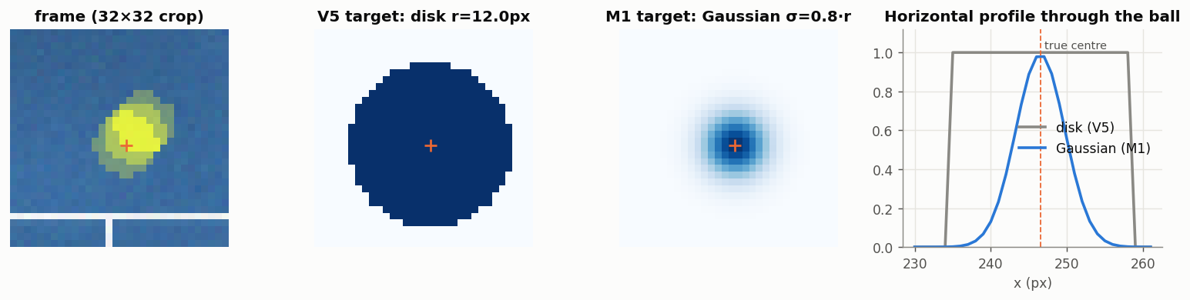

4. Algorithmic steps
Algorithm 1 – Training (run once per model variant)
- Prepare data: render synthetic broadcast clips with exact labels (x, y, visibility), or load real TrackNet clips; resize all frames to 512×288.
- Sample a window of 3 consecutive frames (Iₜ₋₁, Iₜ, Iₜ₊₁); apply a random horizontal flip and brightness/contrast jitter, flipping the labels with the frames.
- Build one target heatmap per frame: a binary disk (V2, V5) or a Gaussian sized to the ball (M1); an empty map when no ball is present.
- Motion decoupling: take grey-level differences between neighbouring frames, split each into positive and negative polarity, and turn each into an attention map with a learnable soft threshold:
P^{\pm} = \mathrm{ReLU}(\pm\Delta), \qquad A = \sigma\big(k(\alpha)\,(P - m(\beta))\big)
V5 learns one (α, β); M2 learns one per frame pair and polarity and adds a direction channel A⁺ − A⁻. The maps are stacked with the RGB frames (13 or 15 channels).
- A U-Net backbone (3×3 convolutions, or depthwise-separable in M4) outputs three draft heatmaps D, one per frame.
- Refinement: D_MDD = D + w·A. A space-time Transformer reads Dropout(D) in V5, or Dropout(D_MDD) in both training and testing in M3, and predicts a residual Δ; the output is D_in + Δ.
- Minimise the weighted binary cross-entropy (from TrackNetV2), which down-weights easy pixels:
\mathcal{L} = -\frac{1}{N}\sum \big[(1-p)^2\, y \log p + p^2 (1-y) \log(1-p)\big]
Optimiser AdamW, gradient clipping at 5, learning rate ×0.1 at 2/3 and 5/6 of training; keep the checkpoint with the best validation F1.
- Real fine-tuning: start from the synthetic checkpoint and repeat steps 2–7 on real games 1–8 at a lower learning rate.
Algorithm 2 – Inference. Split each clip into non-overlapping 3-frame windows, run the network, apply a sigmoid, and decode each heatmap. V2/V5 take the bounding-box centre of the largest blob above 0.5. M1 takes the global peak p* and, if p* ≥ 0.5, returns the centroid of the weights max(p − 0.1·p*, 0) around it, which is unbiased at sub-pixel level.
Algorithm 3 – M5 post-processing (per clip).
- Track the detections with a constant-acceleration Kalman filter on position, velocity and acceleration; trust confident detections more.
- Reject a detection whose innovation exceeds the χ² 99.9 % gate (13.8); two consecutive rejected detections that agree restart the track (a hit or bounce).
- Fill gaps of up to 4 frames with a quadratic fit in time over up to 3 detections on each side (a ball in flight follows a parabola); discard fills that leave the frame.
Algorithm 4 – Evaluation. For every frame, count a true positive when the prediction is within τ = 5.3 px of the label (≈ 13 px at 1280×720), a false positive when it is farther or when no ball is present, and a false negative when the ball is present but missed. Report precision, recall, F1, accuracy and mean localisation error.

5. Dataset used
We use two datasets: a procedural synthetic broadcast generator for pre-training and controlled ablation, and the real TrackNet tennis dataset for fine-tuning and the final test.
Dataset | Content | Split used | Purpose
Synthetic broadcasts (ours) | 150 / 12 / 30 clips × 60 frames at 512×288 (9,000 / 720 / 1,800 frames), exact labels | train / validation / test, all clips independent | Pre-training; ablation with known occlusion, speed and ball size
TrackNet tennis (Huang et al., 2019) | 10 broadcast matches, 95 rally clips, 19,835 labelled frames at 1280×720 | Games 1–8 fine-tune (last clip of each game = validation), games 9–10 test | Fine-tuning and the final real-footage test
Synthetic generator. Each clip renders a perspective tennis court (three surface types), a ball that follows gravity with bounces and racket hits, motion blur along the ball's velocity, two players that chase and occlude the ball, a crowd band with static ball-like specks, camera shake, flicker and sensor noise. The ball radius is about 2.2–5.8 px at 512×288. About 4 % of frames are occluded and about 10 % have no ball (dead-ball segments, used to measure false positives).
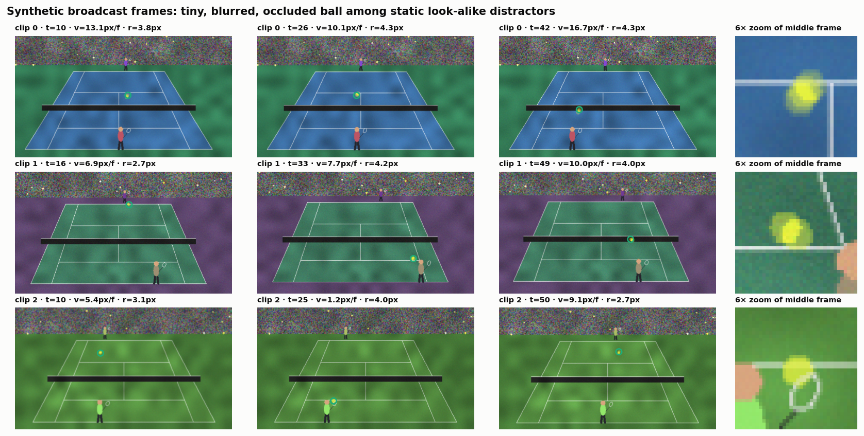
Real dataset. In TrackNet's labels, 17,632 frames have an easily visible ball, 1,392 a hard-to-see ball (blurred or tiny), 82 an occluded ball and 729 no ball. We split by match: neighbouring frames are nearly identical, so a random frame split leaks the test set into training. The two test matches are never seen before evaluation.
Split | Matches | Clips | Labelled frames
Fine-tune | games 1–8 | 66 | 13,806
Validation | last clip of games 1–8 | 8 | 2,312
Test | games 9–10 | 21 | 3,717
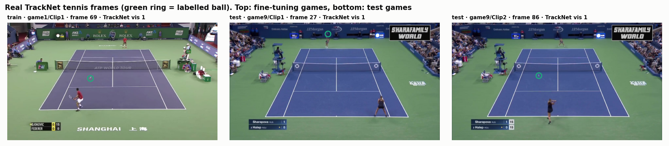

6. Tools used
Training runs on a free Kaggle GPU; development and testing run locally on a laptop CPU.
Category | Tool | Version / detail | Used for
Deep learning | PyTorch | 2.11 + CUDA 12.8 on Kaggle; 2.14 (CPU) locally | Models, training, fused attention (scaled_dot_product_attention)
Compute cost | torch.utils.flop_counter | built into PyTorch | Exact FLOP counts per model
Hardware | Kaggle Notebooks | 2 × NVIDIA Tesla T4 (16 GB each), 29 GB RAM | Pre-training, fine-tuning, evaluation
Image processing | OpenCV | 4.14 | Rendering the synthetic data, loading/resizing frames, contour decoding
Numerics, tables | NumPy, pandas | 2.1, 2.3 | Data arrays, Kalman filter (M5), result tables
Visualisation | Matplotlib, imageio | 3.10 | All figures, table images and the tracking GIF
Notebook | Jupyter, nbconvert | — | The project notebook; headless execution
Testing | pytest | 9.1 | 48 checks that validate every component
Environment | Python, uv, venv | 3.12 locally, 3.13 on Kaggle | Reproducible local setup
Version control | Git, GitHub | — | Code hosting and submission

7. Screenshots of the results
All results come from the full Kaggle run: every model is pre-trained on synthetic data, fine-tuned on real games 1–8 and tested on the unseen games 9–10 (3,717 frames). A detection is correct within τ = 5.3 px at 512×288 (≈ 13 px at 1280×720).
Model cost on the Kaggle Tesla T4 (512×288 input, half channel width, one 3-frame forward pass, batch 1):
Model | Parameters (M) | GFLOPs | Speed (frames/s)
TrackNetV2 (baseline) | 2.836 | 56.5 | 150
TrackNetV5 (faithful) | 3.098 | 66.5 | 82
V5 + M1 | 3.098 | 66.5 | 120
V5 + M1 + M2 | 3.098 | 66.7 | 123
V5 + M1 + M2 + M3 | 2.894 | 57.3 | 217
TrackNetV5-Lite+ (M1–M4, + M5) | 0.410 | 10.9 | 223
Parameters and GFLOPs are exact. Speed is a single timing run: V5 and V5 + M1 have identical compute, so differences of about ±30 % are timing noise. The robust finding is that the slim refinement head (M3) and the depthwise backbone (M4) cut compute by 84 % and roughly double to triple the frame rate.
Accuracy on real broadcast footage (test games 9–10). TrackNetV5-Lite+ with M5 reaches F1 0.841, against 0.918 for the faithful TrackNetV5.
Model | F1 zero-shot | F1 fine-tuned | F1 fine-tuned + M5 | Precision | Recall | Mean error (px)
TrackNetV2 (baseline) | 0.042 | 0.892 | 0.909 | 0.957 | 0.835 | 1.24
TrackNetV5 (faithful) | 0.017 | 0.918 | 0.920 | 0.867 | 0.976 | 1.43
V5 + M1 | 0.009 | 0.926 | 0.955 | 0.968 | 0.888 | 1.36
V5 + M1 + M2 | 0.013 | 0.929 | 0.948 | 0.922 | 0.936 | 1.44
V5 + M1 + M2 + M3 | 0.000 | 0.749 | 0.830 | 0.975 | 0.608 | 1.61
TrackNetV5-Lite+ (M1–M4) | 0.001 | 0.744 | 0.841 | 0.983 | 0.598 | 1.57
Precision, recall and mean error are for the fine-tuned models.
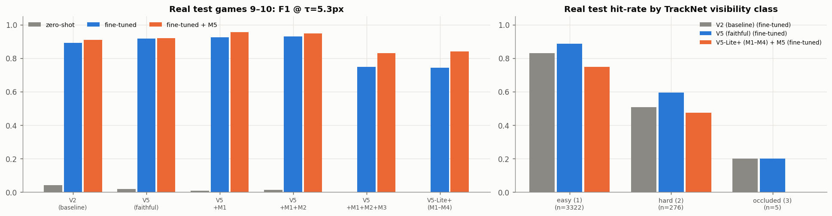
Figure: F1 per model on the real test matches (zero-shot, fine-tuned, fine-tuned + M5), and hit-rate by TrackNet visibility class.
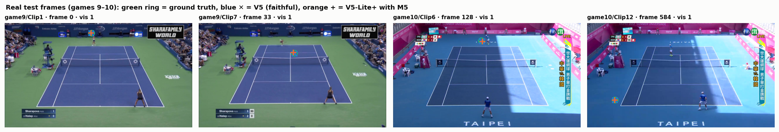
Figure: real test frames with the labelled ball (green), faithful TrackNetV5 (blue ✕) and TrackNetV5-Lite+ with M5 (orange +).
Synthetic test set (controlled ablation).
Model | F1 | Precision | Recall | Mean error (px)
TrackNetV2 (baseline) | 0.980 | 0.974 | 0.985 | 0.70
TrackNetV5 (faithful) | 0.940 | 0.890 | 0.997 | 1.05
V5 + M1 | 0.966 | 0.955 | 0.977 | 1.33
V5 + M1 + M2 | 0.973 | 0.967 | 0.980 | 1.19
V5 + M1 + M2 + M3 | 0.930 | 0.985 | 0.880 | 1.19
TrackNetV5-Lite+ (M1–M4) | 0.943 | 0.986 | 0.903 | 1.27
TrackNetV5-Lite+ + M5 | 0.961 | 0.963 | 0.959 | 1.30
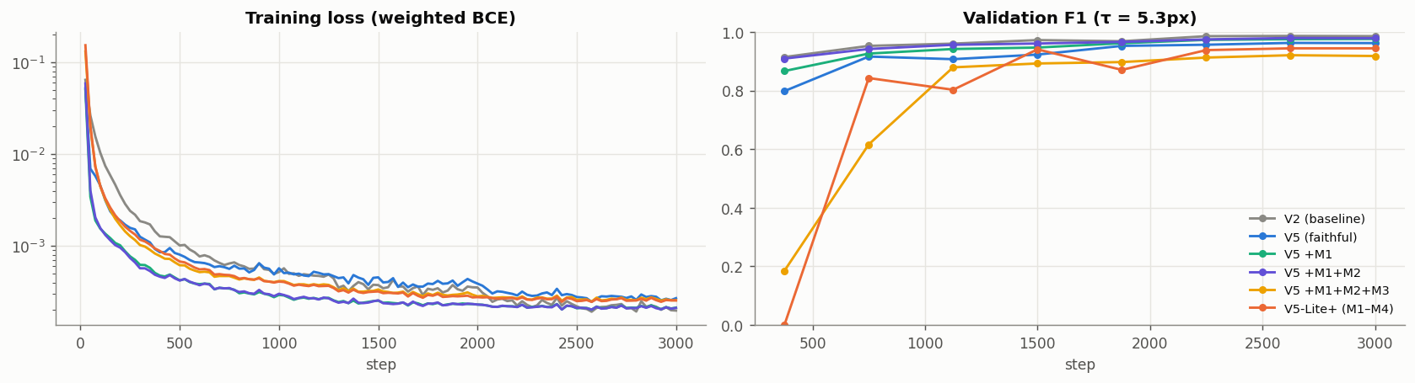
Figure: training loss and validation F1 of the six models.
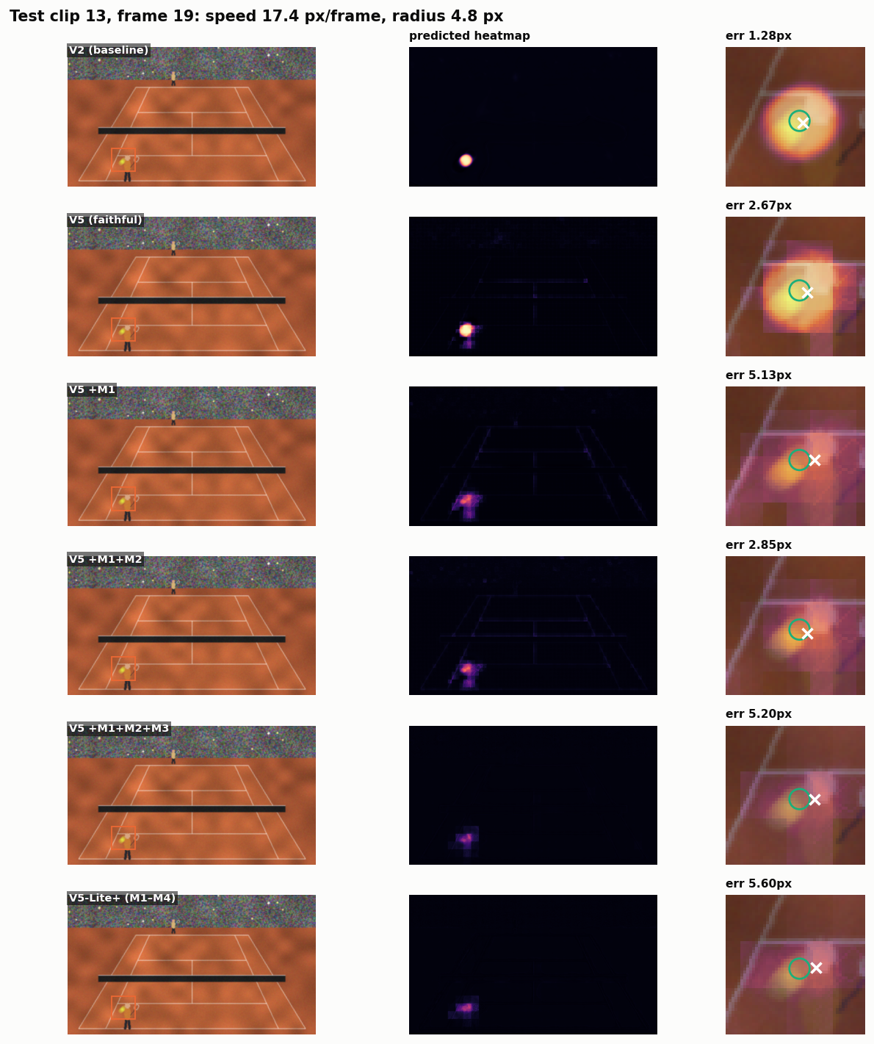
Figure: predicted heatmaps of each model on one fast ball.
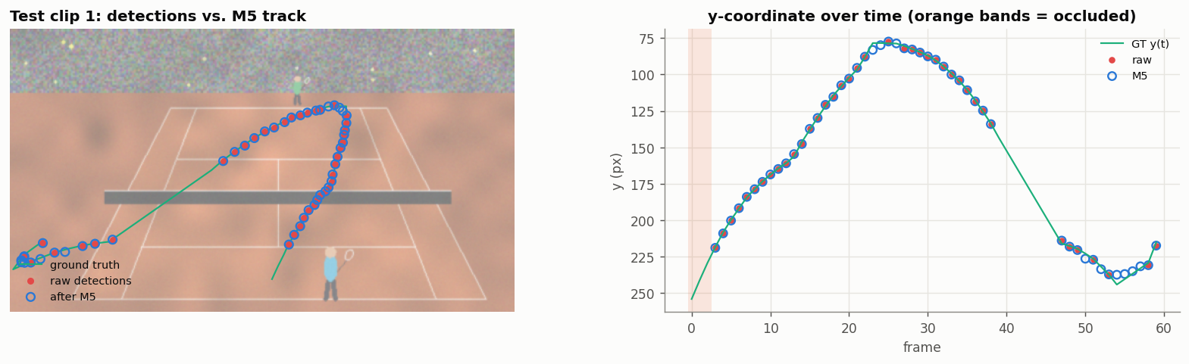
Figure: detections before and after M5 on one test clip.
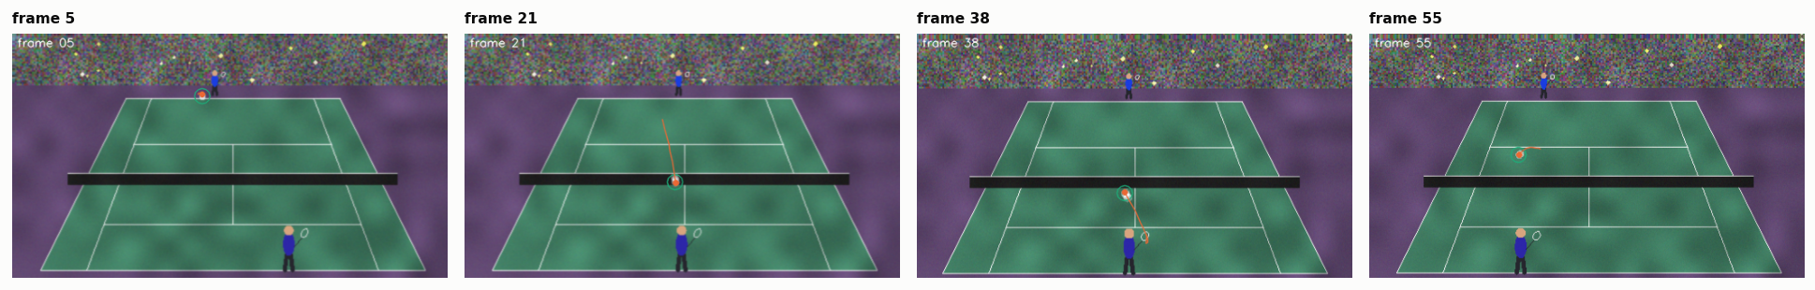
Figure: the final tracker on a full clip (animated version: figures/tracking_demo.gif).

8. Analysis and how it differs from existing approaches
Our approach keeps TrackNet's core idea (heatmaps from consecutive frames) and changes the target, the motion signal, the refinement head, the backbone and the post-processing; every change is measured on its own.
Approach | Motion cue | Training target | Refinement | Post-processing | Occlusion handling | Params at full width
Classical (background subtraction + Kalman) | hand-tuned frame differencing | — | — | track association | coasting | —
TrackNet V1 (2019) | implicit, from 3 stacked frames | 256-class softmax over a Gaussian | — | threshold + Hough circle | none | not reported
TrackNetV2 (2020) | implicit | binary map, weighted BCE | — | blob centre | none | 11.33 M
TrackNetV3 (2023) | background image difference | binary map + mixup | separate learned rectification network | — | inpainting network | not reported
TrackNetV4 (2024) | |frame difference| + learnable power normalisation | binary map | — | blob centre | none | 11.33 M
TrackNetV5 (2025) | signed polarity maps, shared threshold | binary disk, r = 30 px | Transformer residual, train/test input mismatch | blob centre | implicit only | 14.77 M
TrackNetV5-Lite+ (ours) | polarity maps with per-polarity thresholds + direction channel (M2) | ball-size Gaussian, unbiased sub-pixel decoding (M1) | consistent, 4× cheaper head (M3) on a depthwise backbone (M4) | Kalman χ² gating (M5) | ballistic gap filling, no training (M5) | ≈ 1.6 M
What differs in practice.
- Localisation, not just detection. Earlier versions score a hit anywhere inside a wide blob. M1 trains the peak to sit on the ball's centre, so the error can be judged at strict tolerances; we report the full F1-vs-tolerance curve rather than one loose threshold.
- Motion with direction. V4 discarded the sign of the motion; V5 kept it but thresholded both signs identically. M2 lets the network learn separate thresholds and hands it the direction of travel explicitly.
- Consistency. V5's refinement head is trained and tested on different inputs; M3 removes that mismatch at no cost.
- Efficiency measured on hardware. M4 cuts FLOPs by 81 % (57.3 → 10.9 GFLOPs) but raises T4 speed only modestly on its own (217 → 223 frames/s), because depthwise convolutions are memory-bound. FLOPs are not latency.
- Occlusion without a second network. TrackNetV3 needs a trained rectification model; M5 recovers short occlusions with physics alone (a ball in flight follows a parabola) and costs microseconds per frame.
- Honest evaluation. TrackNet V1's 98.5 % F1 came from a random frame split; its own cross-validation over videos dropped to 84.3 %. We test only on two unseen matches.
Published F1 scores (V1 98.5 % on tennis; V2 96.8 %, V4 95.8 %, V5 98.6 % on badminton, as reported in the V5 paper) come from different datasets and splits and are not comparable with ours.
Effect of each change on the real test matches (fine-tuned models).
Change | Compared | ΔF1 | ΔPrecision | ΔRecall | ΔError (px)
M1 Gaussian target + sub-pixel decoding | V5 → V5 + M1 | +0.008 | +0.101 | -0.088 | -0.07
M2 per-polarity motion maps + direction | +M1 → +M2 | +0.003 | -0.045 | +0.048 | +0.08
M3 consistent, slim refinement head | +M2 → +M3 | -0.180 | +0.052 | -0.328 | +0.17
M4 depthwise-separable backbone | +M3 → +M4 | -0.005 | +0.009 | -0.010 | -0.04
M5 Kalman gating + gap filling | M1–M4 → +M5 | +0.097 | -0.030 | +0.154 | +0.10
Total | V5 → V5-Lite+ with M5 | -0.077 | +0.087 | -0.224 | +0.23
Fine-tuning on real games 1–8 changes the mean F1 from 0.014 (zero-shot) to 0.860. The largest single gain comes from M1 Gaussian target + soft-argmax (ΔF1 +0.008), and M5 changes F1 by +0.097. Each result is a single seed, so differences below about 0.01 F1 are treated as noise.
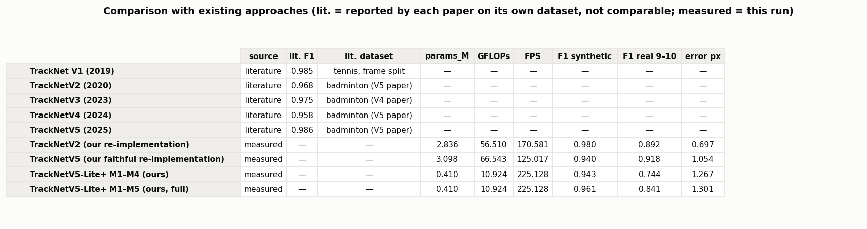
Figure: comparison with existing approaches (literature values on their own datasets; measured values from this run).

9. Code link
- GitHub repository: github.com/VirajM723/DL-project – the notebook TrackNetV5_TinyObject_Tracking.ipynb, README.md (setup and Kaggle steps), CHANGES.md (every change vs. the paper), tests/ (48 checks), figures/ and results/.
- Kaggle notebook (executed, with all outputs): add the public link of the final committed version here.

10. Novel contribution
We contribute five model changes and an evaluation setup; each change targets one gap from Section 2 and is measured in isolation.
- M1 – Ball-size Gaussian targets with an unbiased sub-pixel decoder. Targets are Gaussians whose width follows the ball's radius (σ = 0.8 × radius) instead of V5's 60-px disk. Decoding takes a centroid of the weights max(p − 0.1·peak, 0), which our tests show is unbiased (< 0.05 px error on ideal peaks, vs. 0.24 px for a plain 5×5 centroid).
- M2 – Polarity-specific motion decoupling. Separate learnable slope and threshold for each frame pair and each polarity (4 instead of 1), plus an explicit signed direction channel A⁺ − A⁻.
- M3 – Consistent, slim refinement head. We identified V5's train/test input mismatch in the refinement Transformer and removed it; 16-px patches (vs. 8) cut its tokens 4×, its parameters by 78 % and its compute by more than 90 % (the whole model drops from 66.7 to 57.3 GFLOPs on the T4).
- M4 – Depthwise-separable TrackNet backbone. 7.6× fewer parameters and 6× fewer FLOPs than the faithful V5, with the latency gap between FLOPs and real speed measured on hardware.
- M5 – Physics-aware, training-free post-processing. A constant-acceleration Kalman filter with χ² gating removes isolated false positives (V5's stated failure mode) and ballistic gap filling recovers occluded frames, with no extra network.
- Evaluation contributions. A procedural broadcast generator with exact occlusion, speed and size labels; a match-level sim-to-real protocol on the TrackNet tennis dataset; a one-change-at-a-time ablation; and a 48-check test suite that found and fixed five bugs before training (including occlusion labels that were wrong in 71 % of cases).

11. Individual contribution
The work splits into three parts of similar size: data and evaluation, models and training, and post-processing with analysis.
Member | Area | Contributions | Notebook sections
Harshit | Data and evaluation | Literature review of TrackNet V1–V5 and the problem framing; the synthetic broadcast generator (court, ball physics, motion blur, occluding players, camera shake); the real TrackNet tennis loader and the match-level split; training targets (disk vs. Gaussian, M1 targets); the evaluation protocol and metrics (TP/FP/FN, F1 at tolerance τ) | §1, §3, §4, §7 metrics
Viraj | Models and training | Re-implementation of TrackNetV2 (U-Net backbone) and the faithful TrackNetV5 (motion decoupling, Transformer refinement head); modifications M2, M3 and M4; the weighted BCE loss and training loop; synthetic pre-training and real-data fine-tuning on the Kaggle GPU; the model-cost measurements | §5, §6, §9.5
Bahul | Post-processing, analysis and reporting | M1 sub-pixel decoder and M5 Kalman post-processing; the ablation study and comparison with existing approaches; all figures and visual analysis (heatmaps, motion maps, refinement, tracking GIF); the pytest suite and bug fixes; README, CHANGES.md and this report | §8, §9, §10–12, tests/

12. Learning outcome
The project taught us how to read a recent paper critically, turn its equations into working code, and measure whether each change actually helps.
- Reading research critically. Writing V5 from its equations exposed details a quick read misses: an absolute value with no effect, a train/test input mismatch, and an unspecified head size we had to choose ourselves.
- Dense prediction for tiny objects. Why heatmap regression with U-Net skip connections beats box detectors when the object is a few pixels wide, and how the choice of target (disk vs. Gaussian) changes what the network learns.
- Temporal deep learning. Using frame differences as explicit motion cues, and factorised space-time attention (TimeSformer-style) for refinement across frames.
- Class imbalance. Over 99.9 % of pixels are background; the focal-style weighted BCE is what makes training possible.
- Classical estimation still matters. A Kalman filter with gating and a parabola fit adds robustness that no extra network layer gave us, at almost no cost.
- Efficiency is a hardware question. FLOPs fell 81 % with depthwise convolutions while speed barely moved; deployment claims need wall-clock measurements.
- Honest evaluation. Splitting by match instead of by frame, keeping a validation set for checkpoint choice, and separating literature numbers from our own measurements.
- Engineering for reproducibility. Synthetic data with exact labels, smoke-test runs, a 48-check test suite that caught wrong labels on 71 % of "occluded" frames and a crash before training, and running long jobs on free cloud GPUs (Kaggle).

13. AI tool usage
Claude was used to help with parts of the coding and with compiling this report. The original research, the testing and the verification of the results were carried out by the team members.

References
- Y.-C. Huang, I-N. Liao, C.-H. Chen, T.-U. İk, W.-C. Peng. TrackNet: A Deep Learning Network for Tracking High-speed and Tiny Objects in Sports Applications. IEEE AVSS 2019.
- N.-E. Sun et al. TrackNetV2: Efficient Shuttlecock Tracking Network. ICPAI 2020.
- Y.-J. Chen, Y.-S. Wang. TrackNetV3: Enhancing ShuttleCock Tracking with Augmentations and Trajectory Rectification. ACM MM Asia 2023.
- A. Raj, L. Wang, T. Gedeon. TrackNetV4: Enhancing Fast Sports Object Tracking with Motion Attention Maps. arXiv 2024 (ICASSP 2025).
- H. Tang, Y. Chen, L. Jiang. TrackNetV5: Residual-Driven Spatio-Temporal Refinement and Motion Direction Decoupling for Fast Object Tracking. arXiv 2025.
- O. Ronneberger, P. Fischer, T. Brox. U-Net: Convolutional Networks for Biomedical Image Segmentation. MICCAI 2015.
- G. Bertasius, H. Wang, L. Torresani. Is Space-Time Attention All You Need for Video Understanding? (TimeSformer). ICML 2021.
- T.-Y. Lin et al. Focal Loss for Dense Object Detection. ICCV 2017.
- A. G. Howard et al. MobileNets: Efficient Convolutional Neural Networks for Mobile Vision Applications. 2017.
- R. E. Kalman. A New Approach to Linear Filtering and Prediction Problems. 1960.

